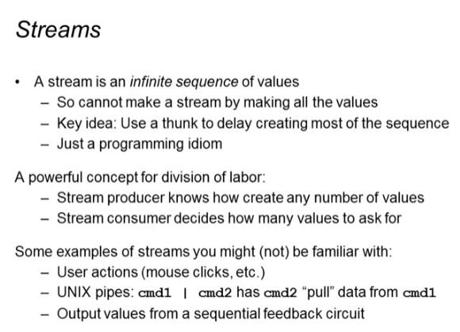

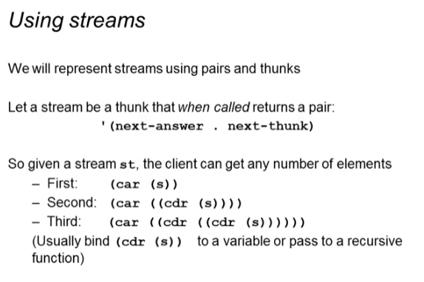

Using streams

powers-of-two Function



Calling the thunk

* Returns the pair ‘(next-answer . next-thunk)



1st thing in the sequence



2nd thing in the sequence



3rd thing



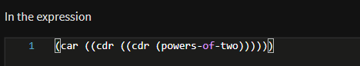



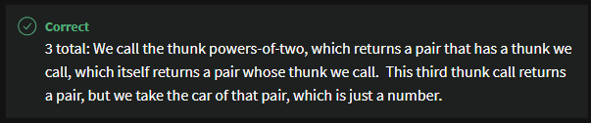

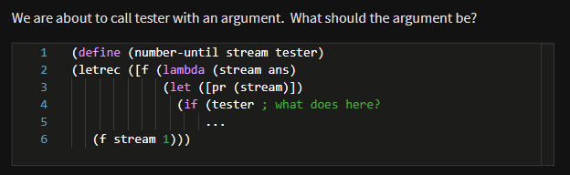

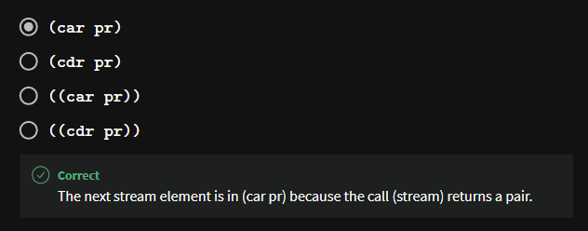

number-until

* Returns the number of times the stream is called until true

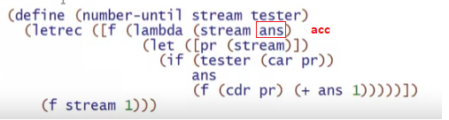



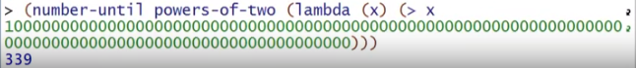

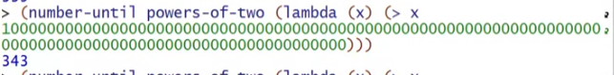

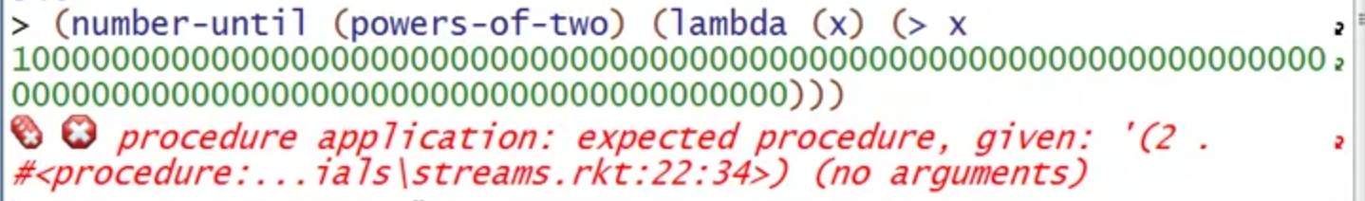

* This is a pair NOT A THUNK